**Research Report**

Researching Entertainment Event Applications

Author: N. Packham

15th February

Summary Word Count: 50

Main Text Word Count: 2434

**Summary**

This report delves into the research of entertainment event applications. It starts by examining the targeted audience and logic used for large and small-scale entertainment event applications. Next it focuses on a thorough evaluation of a relevant website, before concluding with a basic concept idea for an entertainment event application.

**Contents**

1: Introduction ……………………………………………………….……………………...................1

2: Entertainment Event Application Research ……….…………………………………...............1

2.1: Application Design…….…………………………………………….………………….1

2.2: Target Audience ……….…………………………………………….………………….1

2.3: Examples of Entertainment Event Applications …….…...……….………………….1

3: Ashton Gate Stadium - Website Review ….……….…………………………………...............2

3.1: Ashton Gate Stadium - ‘HOME’ Page …………………………….………………….3

3.2: Ashton Gate Stadium - ‘WHAT’S ON’ Page ……….…...……….………………….5

3.3: Ashton Gate Stadium - ‘GETTING HERE’ Page …….…...……….…….………….7

4: Conclusion …………………………….….……….……………………………….….............10

5: References …………………………….….……….……………………………….….............11

**1: Introduction**

Our team has made the decision to focus on creating an Entertainment Event application. Each member will take on a different event and conduct the necessary research, design, and then produce a prototype for the relevant application. Upon completion, we will seamlessly integrate all the event sub-applications into a comprehensive final Entertainment Event platform.

**2: Entertainment Event Application Research**

**2.1: Application Design**

Entertainment Event applications come in all different formats. The larger companies such as Ticketmaster, Glastonbury Festival and Wembley Stadium, tend to cover all bases and produce a website and a mobile application. This is a wise strategy for larger companies with a large customer base. By offering a mobile application, you provide your frequent customers with a faster, more convenient, and personalised way to access your services. Studies show that users prefer mobile apps to websites (Whiz Solutions, 2019). Smaller companies such as Wotton Cinema and Pulse Dursley (swimming pool), prefer to use just a website. Only using a website is cost-effective and convenient (Summerfield, n.d.), and an ideal solution for smaller companies. Not only is it more cost efficient, but websites can still act like mobile applications and can be a practical alternative (Summerfield, n.d.).

**2.2.: Target Audience**

As there can be many different types of events, it is hard to focus on one target audience. Generically, events have the potential to reach a wide range of people, including those who reside in the vicinity of the event, enthusiasts of the event's genre, and tourists seeking new experiences. This broad target audience presents a unique opportunity for our Entertainment Event platform to connect and cater to a diverse group of people.

However, as each member is specialising in a specific event for their sub-application, the task of targeting a specific audience becomes much more manageable. I have selected stadium events as the focus for my sub-application. Stadiums offer a wide range of events, each presenting a unique opportunity to target the relevant audience. For example, when a football match takes place at the stadium, the target audience should be primarily the local community. This can be confirmed by a study the Telegraph conducted in 2017. It shows a heatmap of Great Britain, this heatmap indicates the fan clusters for each premier league football club. Although there are clusters all around Great Britain, it clearly indicates that most fans for each club are local (Telegraph, 2017). Conversely, if a popular music artist is scheduled to perform, our focus should shift towards their dedicated fanbase, whether this be within the local community or further afield.

**2.3: Examples of Entertainment Event Applications**

Ticketmaster serves as a great example of a company that excels in the entertainment events sector (<https://www.ticketmaster.co.uk>). Their website and mobile application are utilized by millions of people per month (Daniel, 2023) and offer a wide range of events including music concerts, football matches, comedy shows, and more. With the ability to sell and facilitate re-sales of tickets, Ticketmaster has established itself as a leading player in this industry. Ticketmaster operates with a straightforward approach to event ticketing. Upon accessing their home screen, users are presented with a list of upcoming events, along with a search function to easily find their desired event. Once the event is selected, Ticketmaster searches for available tickets and presents the option to purchase them. Upon successful purchase, the buyer will receive a confirmation email along with their e-tickets.

My local cinema, Wotton Cinema (https://www.wottoncinema.com), serves as an example of a smaller business that specializes in entertainment events within the film industry. With a minimalist approach, they offer a simple website that effectively meets the needs of their customers. However, it follows the same basic approach to event ticketing as Ticketmaster. The home screen showcases all the upcoming movie screenings, and a "What's On" page gives a comprehensive view of the films being shown. Customers have the option to conveniently book their tickets online through the "Book Online" feature, where they can complete the payment and receive their e-tickets via email.

When comparing two websites that exist at either end of the entertainment event spectrum, it is surprising the similarities they share. Regardless of the size and scale, be it a worldwide giant like Ticketmaster or a local treasure like Wotton Cinema, the fundamental logic of the website and/or app design prevails.

Subsequently, I have conducted an in-depth review of the Ashton Gate Stadium website. My aim is to create a sub-application for stadium events as part of my contribution to this project, and that's why I chose to focus my examination on this website. Please see the full review in section 3.

**3: Ashton Gate Stadium – Website Review**

I have chosen to review the website of Ashton Gate Stadium. Ashton Gate Stadium is a multi-purpose stadium located in Bristol, UK. For my contribution towards the final Entertainment Events application, I would like to create something similar which focusses on stadium/sports events.

For this review of the Ashton Gate Stadium website, I will be scrutinizing the "HOME," "WHAT'S ON," and "GETTING HERE" pages. These pages encapsulate the essential elements that any stadium/sports events website should possess. By evaluating these pages, I hope to gain a deeper insight into the design process and determine the best approach for my stadium/sports events sub-application.

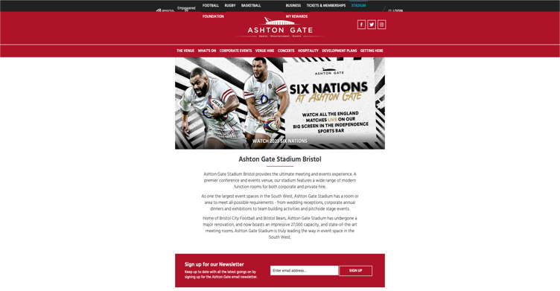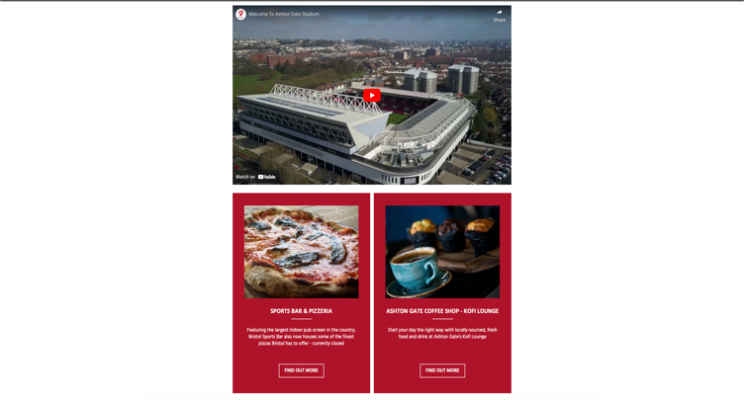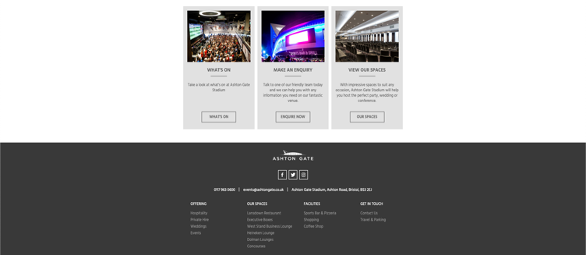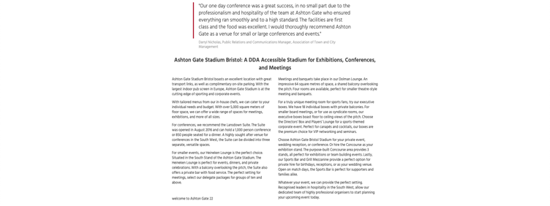

The header of the website, which includes links to all the different sections of the website.

A reel of all the upcoming events at the stadium.

A video about the stadium from YouTube.

Badges used to highlight the restaurants and cafes within the stadium.

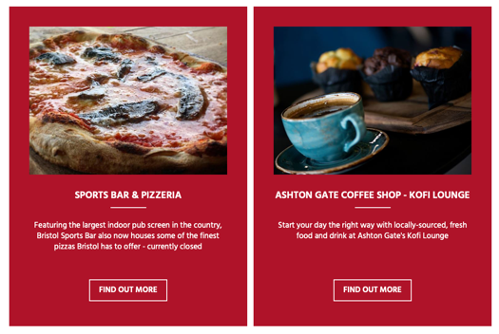

A quoted review from someone who came to a conference at the stadium.

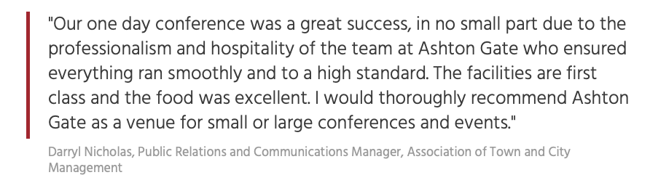

Badges used to highlight some of the more important sections of the website.

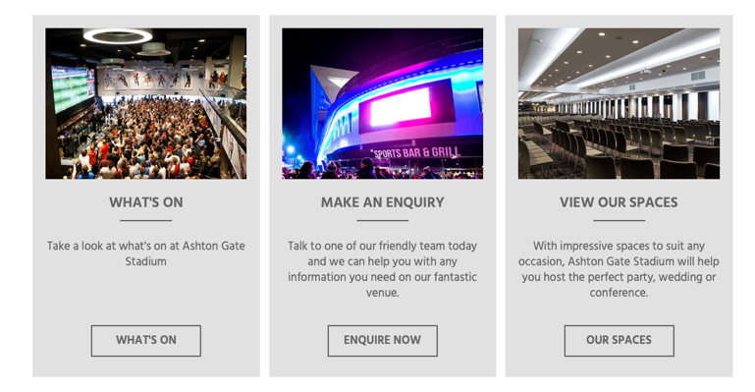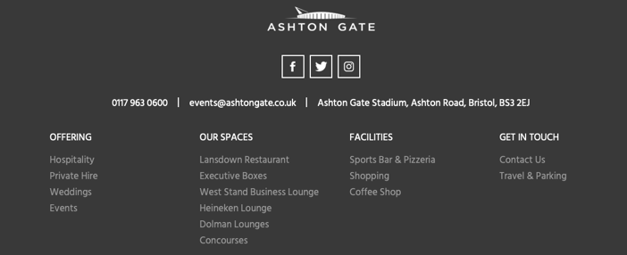

The footer of the website which includes the entire contents of the website.

An in-depth summary of the capabilities that the stadium can provide regarding hosting exhibitions, conferences, and meetings.

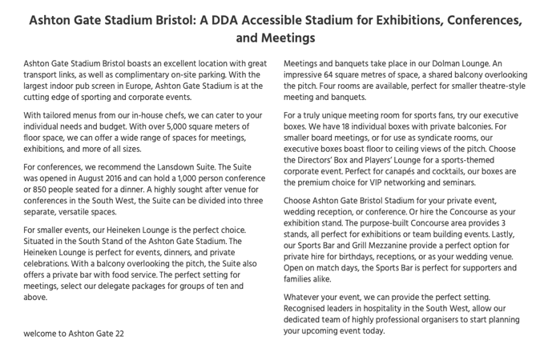

Information about the stadium, as well as the option to sign up to the stadium newsletter.

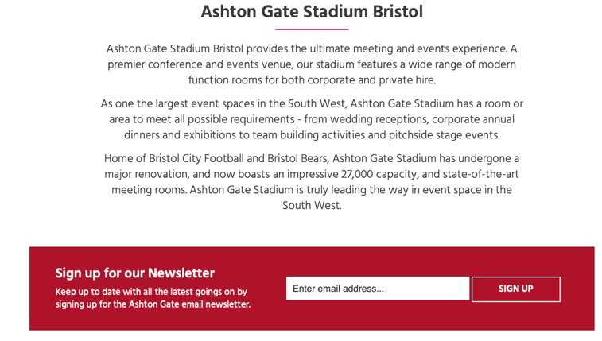

**3.1: Ashton Gate Stadium – ‘HOME’ Page**

Figure 1: Ashton Gate Stadium annotated ‘HOME’ Page. Source: Aston Gate Stadium-a (n.d.) Ashton Gate Stadium – ‘HOME’ Page, accessed 11 February 2023. https://www.ashtongatestadium.co.uk

Home pages need to wear a lot of hats (Cox, 2022) and the home page for the Ashton Gate Stadium certainly does this, with a significant amount of information available as soon as the website loads. The Ashton Gate Stadium website offers a very informative home page, providing users with an abundance of information. While this can certainly be beneficial, it may also feel overwhelming at times. As Standberry (2022) explains, simple website designs are the best website designs. He goes on to say that this can be proven by several case studies and focus groups. As a seasoned web user and a novice web developer, I concur with Standberry's (2022) assessment. In my view, the design of the home page for Ashton Gate Stadium’s website is overcomplicated and displays a great deal of unwanted information.

However, the elements I am impressed with are:

* At the top of the homepage, the user is greeted by a scrolling reel showcasing the various upcoming events. This prominent feature serves as an attention-grabbing introduction to the site.
* The title and information about the stadium. These are crucial elements for any website home page. As Cox (2022) correctly notes, a website's headline should immediately communicate to visitors what the business has to offer within a matter of seconds. The sub-headline should complement the headline and offer a sufficient overview of the website's offerings.
* A quoted review from a happy customer. Reviews can hold significant sway over users (Oyinloye, n.d.), with research by Elliot (n.d.) revealing that a staggering 97% of customers indicate that reviews influence their purchasing decisions. Given this substantial figure, displaying positive reviews can prove highly advantageous for a website.
* Visual badges with images, displaying the main sections of the website. This feature allows users with prompt and effortless access to the pages that may interest them, eliminating the need to search through menus.

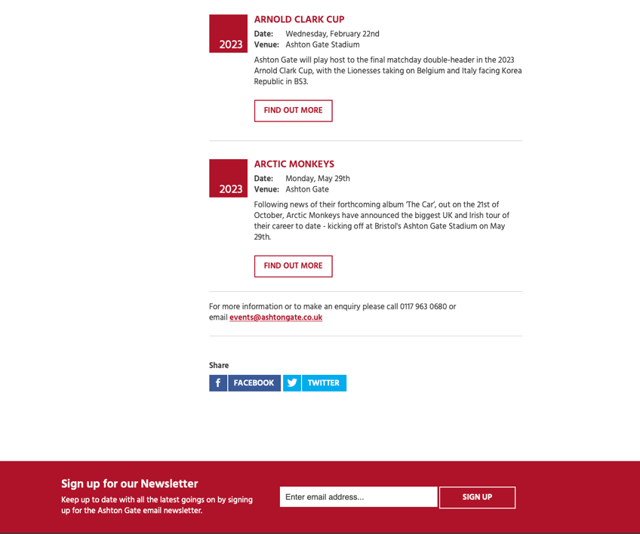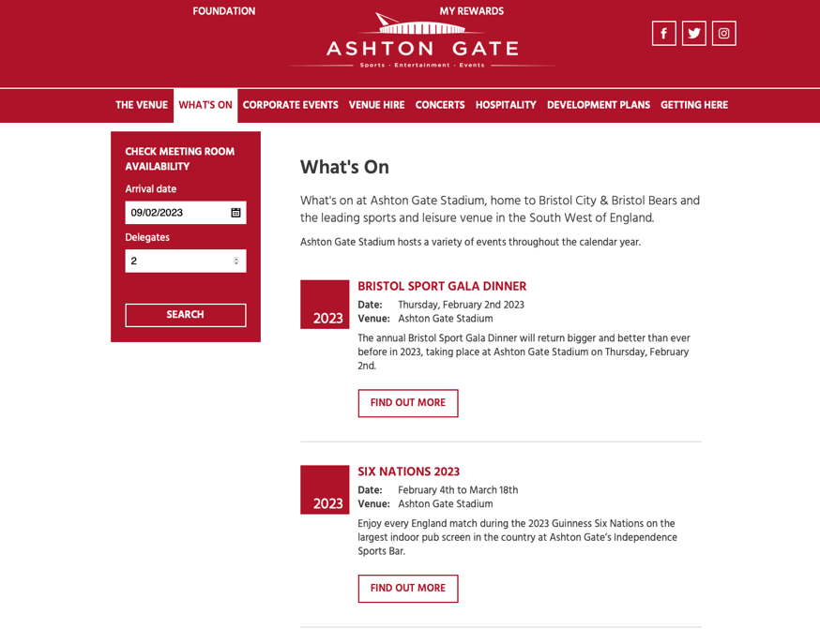

A separate function to allow the user to search for all available meeting rooms on a specific date.

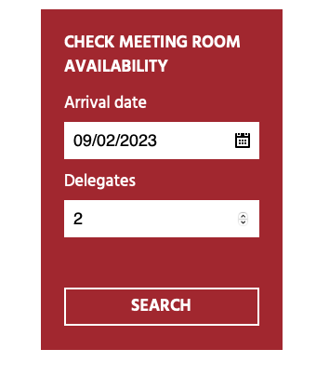

A badge displaying a single event.

The elements within the badge include: the events name, the date the event is on, the location where the event is taking place and a short description of what the event is. Also included is a button which takes the user to a different page, this page has more information about this event.

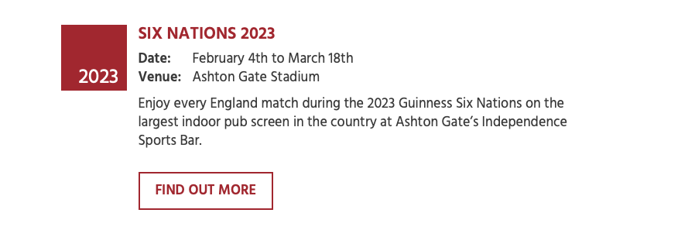

Contact details if the user has any questions that have not be answered by the information provided on this page.

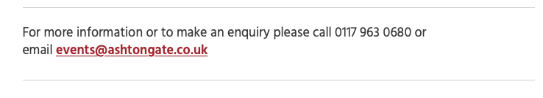

A short introduction to the ‘WHAT’S ON’ page.

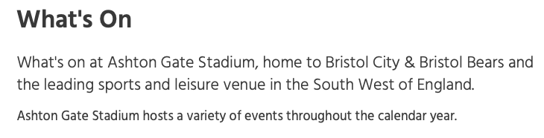

**3.2: Ashton Gate Stadium – ‘WHAT’S ON’ Page**

Figure 2: Ashton Gate Stadium annotated ‘WHAT’S ON’ Page. Source: Aston Gate Stadium-b (n.d.) Ashton Gate Stadium – ‘WHAT’S ON’ Page, accessed 11 February 2023. https://www.ashtongatestadium.co.uk/whats-on/

For most users, the primary reason for visiting the Ashton Gate Stadium website is to view the "WHAT'S ON" page. As noted in the ‘HOME’ page review, Standberry (2022) explained that a simple web design is often the most effective. The design of this page embodies this principle, resulting in a highly effective user experience. The page begins with a sufficient introduction, followed by a display of upcoming events presented as straightforward badges. These badges provide users with all the necessary information for each event, including a button to access further information and purchase tickets. At the bottom of the page, there is a section featuring the stadium's contact details, for any additional enquires.

I was also impressed with the feature that enables users to search for available meeting rooms with ease. This intuitive tool saves users the time and effort of having to make inquiries via email or phone, streamlining the process of finding availability.

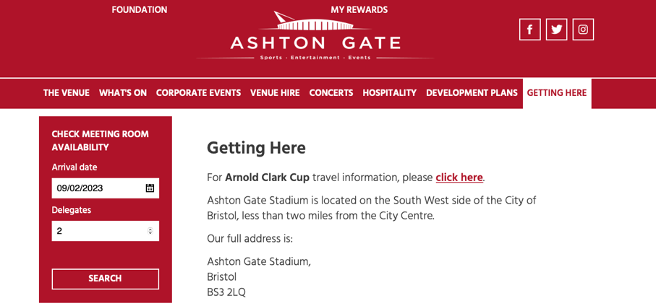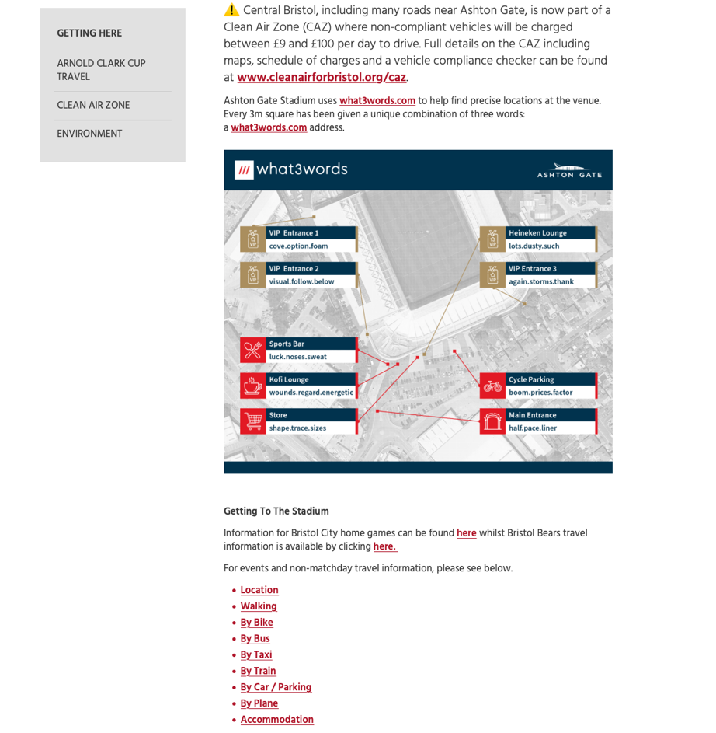

Links to relevant external pages regarding travel.

Introduction to the ‘Getting to The Stadium’ section.

Arnold Clark Cup is a new upcoming event; hence this has been put to the top, so it is read first.

Following any new event information, the full address of the stadium is provided.

A warning about the newly implemented ‘Clean Air Zone’ in Bristol and information about this including prices and a link to the ‘Clean Air Zone’ website.

Information on What3words.com. This can be used by visitors to the stadium to find where they are going once they are outside.

**3.3: Ashton Gate Stadium – ‘GETTING HERE’ Page**

Figure 3: Ashton Gate Stadium annotated ‘GETTING HERE’ Page (1/3). Source: Aston Gate Stadium-c (n.d.) Ashton Gate Stadium – ‘GETTING HERE’ Page, accessed 11 February 2023. https://www.ashtongatestadium.co.uk/getting-here/

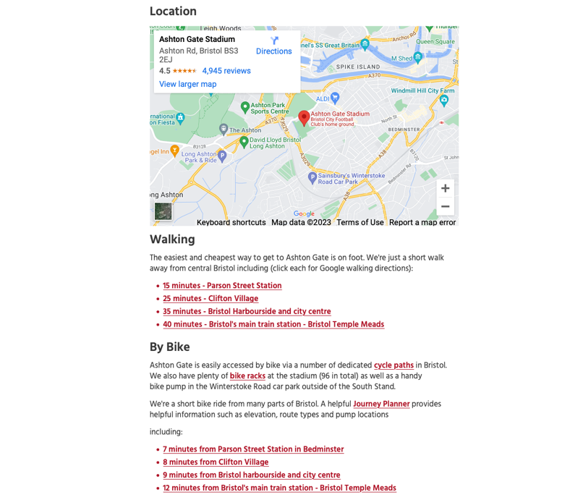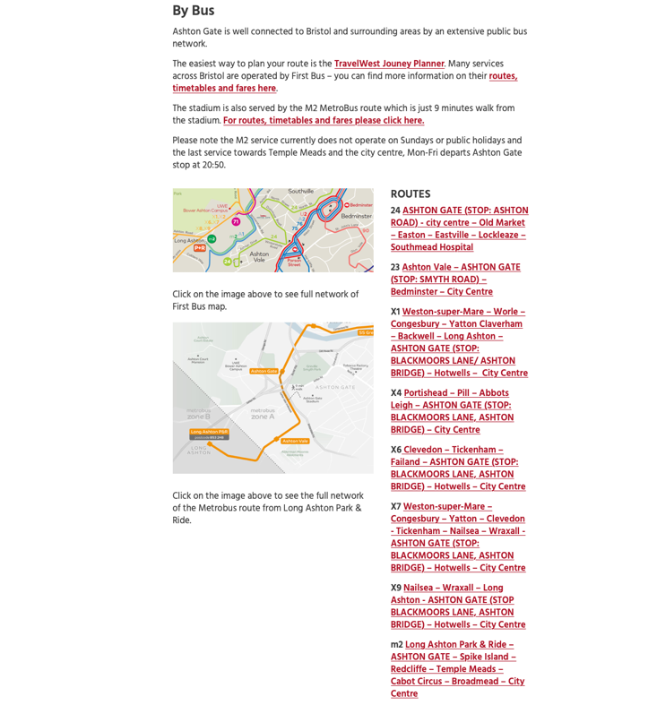

The exact location of the stadium on a map. This map can also be clicked by the user to be redirected to this location on Google Maps.

Information on walking to the stadium. Links have been provided from different walkable locations within the city. The links redirect the user to Google Maps, where the route is mapped out.

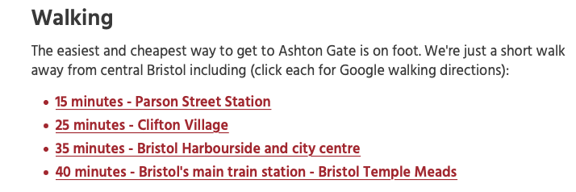

Information on riding a bike to the stadium. Links have been provided from different locations within the city (same locations as the ‘Walking’ section). The links redirect the user to Google Maps, where the route is mapped out.

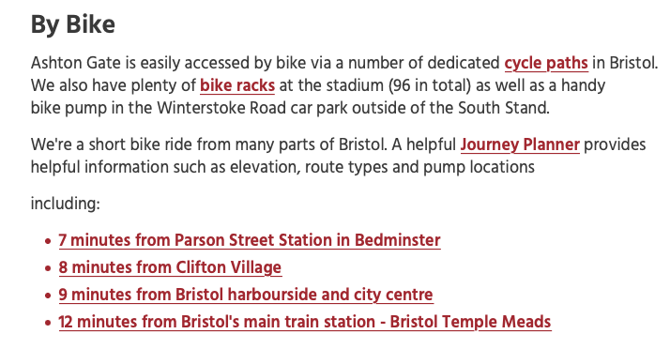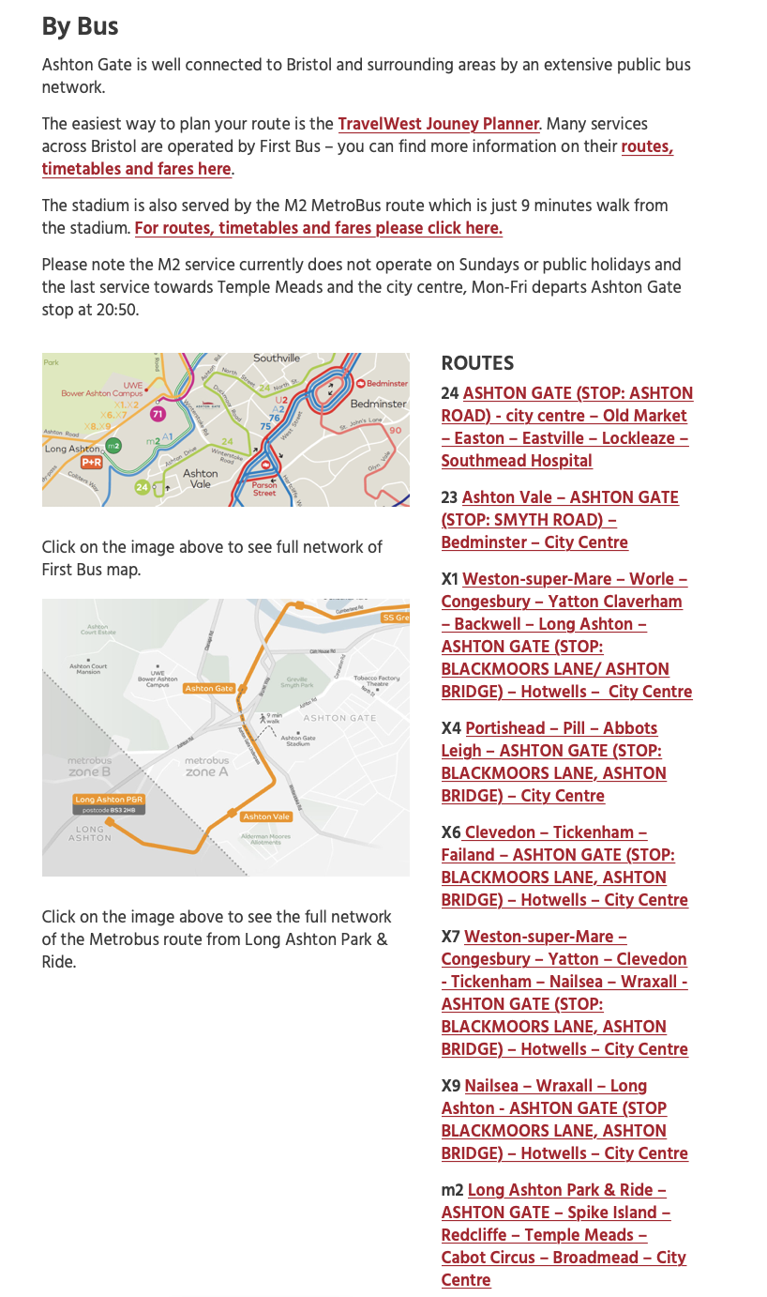

Information on getting to the stadium via a bus. The links provided are all the routes that stop near the stadium. These links will redirect you to specific route’s bus timetable.

Figure 4: Ashton Gate Stadium annotated ‘GETTING HERE’ Page (2/3). Source: Aston Gate Stadium-c (n.d.) Ashton Gate Stadium – ‘GETTING HERE’ Page, accessed 11 February 2023. https://www.ashtongatestadium.co.uk/getting-here/

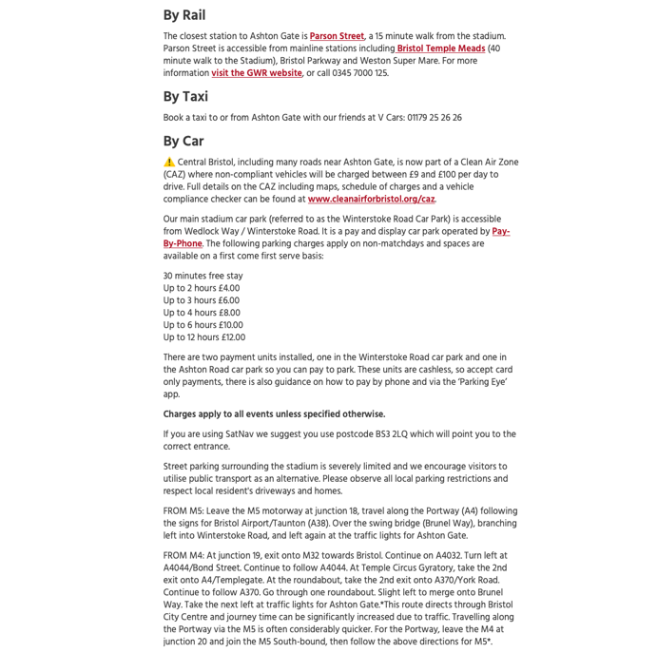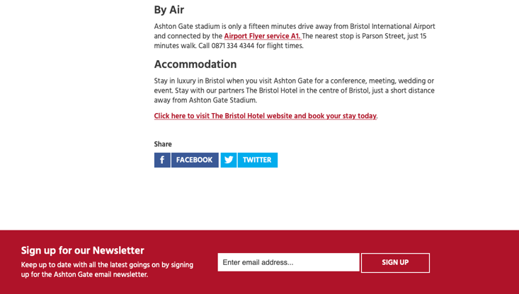

Information about getting to the stadium by rail. This information includes the closest train station, the ‘main’ train station within Bristol and a link to the GWR (Great Western Railway) website which will have all the timetables for trains to and from these stations. have all the timetables on.

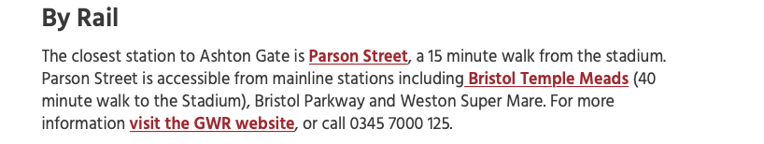

Information about a taxi company that would be willing to do taxi runs. This must be a paid partnership to be included on the website.

Information about the Bristol Hotel which is their partner. This must be a paid partnership for it to be included on the website.

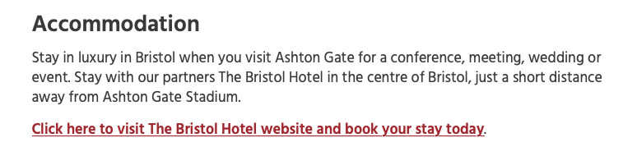

Information on travelling to the stadium via air. This information includes the airport’s location in regards to the stadium’s location, and how to get to the stadium from the airport.

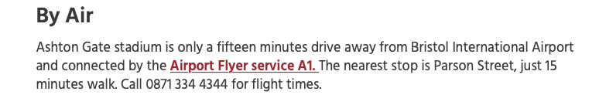

An in-depth description of travelling to the stadium via car. This information includes another reminder of the ‘Clean Air Zone’, car parks, car park prices, which postcode to use when using a sat-nav and directional information when coming from either M5 or M4.

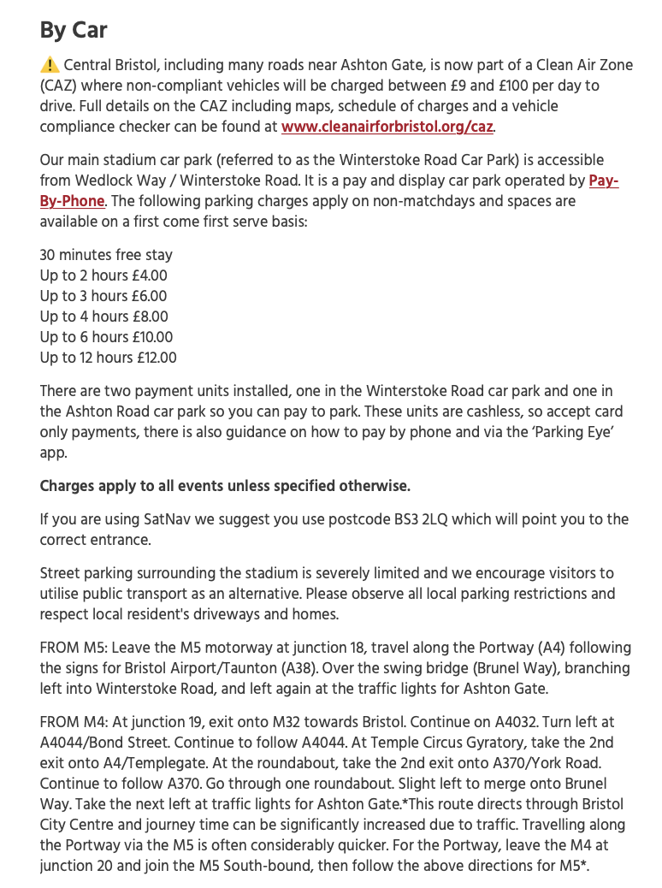

Figure 5: Ashton Gate Stadium annotated ‘GETTING HERE’ Page (3/3). Source: Aston Gate Stadium-c (n.d.) Ashton Gate Stadium – ‘GETTING HERE’ Page, accessed 11 February 2023. https://www.ashtongatestadium.co.uk/getting-here/

Although I have consistently expressed my agreement with Standberry's (2022) stance on the use of simple web designs, I must acknowledge that there may be instances where prioritising impact over simplicity is warranted in web design. Transportation to an event is a crucial aspect, and Ashton Gate Stadium has provided comprehensive information on all modes of travel to the stadium. From a customer's perspective, this detailed guidance provides confidence and peace of mind in arriving at the stadium in a timely and safe manner.

The elements I am impressed with are:

* Travel information on a new upcoming event - At the top of the webpage, specific travel information has been featured for the upcoming "Arnold Clarke Cup" event, indicating its significance. This placement allows all attendees to immediately access this information upon visiting this webpage, ensuring they are well-informed and prepared for the event.
* A warning with an explanation about the ‘Clean Air Zone’ - Bristol recently implemented a ‘Clean Air Zone’ within its city (bristol.gov.uk, n.d.). Highlighting this is essential, as for visitors traveling to the stadium by car, failing to pay the charge for the "Clean Air Zone" could result in substantial fines.
* An explanation on getting to the stadium via each mode of transport. This includes but is not limited to:
  + Bus timetable links.
  + A detailed description on how to get to the stadium via car. According to data from gov.uk (2022), cars, vans, and taxis account for 88% of passenger kilometres travelled in Great Britain, making this information highly relevant for many visitors.

While I appreciate the features offered on the ‘GETTING HERE’ webpage, I do find it confusing to see the "Available Meeting Rooms" search feature. It does not seem to be relevant to the main purpose of visiting the stadium and in my opinion this feature should not be on this webpage at all.

**4: Conclusion**

After thorough research, I have formulated an initial concept for our Entertainment Events application. The primary objective of this project will be to develop a user-friendly and accessible website. This website will be dedicated to presenting extensive coverage of events taking place. From concerts and movie screenings to sporting events and more, it will provide users with all the relevant information they need, including ticketing news and more. This approach will allow us to cater to a wider audience and provide a comprehensive solution for all their entertainment needs.

The home screen can showcase the identity of our website, along with important information about the websites concept. To streamline access to all the sub-applications produced by each team member, we can integrate a user-friendly navigation bar with easy-to-follow links.

Here are some innovative ideas for sub-applications to be included in our main website: Sporting Events, Health & Fitness Events, Music & Film Events and Theme Park News.

**5: References**

Ashton Gate Stadium-a (n.d.) Ashton Gate Stadium – ‘HOME’ Page [online image]. Available at: https://www.ashtongatestadium.co.uk [Accessed: 11 February 2023]

Ashton Gate Stadium-b (n.d.) Ashton Gate Stadium – ‘WHAT’S ON’ Page [online image]. Available at: <https://www.ashtongatestadium.co.uk/whats-on/> [Accessed: 11 February 2023]

Ashton Gate Stadium-c (n.d.) Ashton Gate Stadium – ‘GETTING HERE’ Page [online image]. Available at: <https://www.ashtongatestadium.co.uk/getting-here/> [Accessed: 11 February 2023]

bristol.gov.uk (n.d.) ‘Bristol’s clean air zone chargers and vehicle checker’, bristol.gov.uk, accessed 11 February 2023. <https://www.bristol.gov.uk/residents/streets-travel/bristols-caz/charges-and-vehicle-checker>

Cox L K (01 April 2022) ’12 critical elements every website homepage must have [infographic]’, HubSpot, accessed 11 February 2023. <https://blog.hubspot.com/blog/tabid/6307/bid/31097/12-critical-elements-every-homepage-must-have-infographic.aspx>

Daniel C (2023) ‘Ticketmaster revenue and growth statistics (2023)’, SignHouse, accessed 11 February 2023. <https://www.usesignhouse.com/blog/ticketmaster-stats>

Elliot K (n.d.) ‘Online review statistics to improve your company’s reputation’, nicejob, accessed 11 February 2023. <https://get.nicejob.com/resources/online-review-statistics-to-improve-your-companys-reputation>

gov.uk (15 December 2022) ‘’, gov.uk, accessed 11 February 2023. <https://www.gov.uk/government/statistics/transport-statistics-great-britain-2022/transport-statistics-great-britain-2022-domestic-travel>

Oyinloye M (n.d.) ‘Why customer reviews are important and how to get more’, nicejob, accessed 11 February 2023. <https://get.nicejob.com/resources/why-customer-reviews-are-important-and-how-to-get-more>

Standberry S (2022) ‘Why simple website design is the best website design’, Lyfe Marketing, accessed 11 February 2023. <https://www.lyfemarketing.com/blog/simple-website-design/>

Summerfield J (n.d.) ‘Mobile website vs. mobile app: which is best for your organization’, Human Service Solutions, accessed 11 February 2023. <https://www.hswsolutions.com/services/mobile-web-development/mobile-website-vs-apps/>

Telegraph (17 August 2017) ‘Every premier league club’s fans mapped – how local is your team’s support?’, Telegraph, accessed 11 February 2023. <https://www.telegraph.co.uk/football/2017/08/17/every-premier-league-clubs-fans-mapped-local-teams-support/>

Whiz Solutions (31 May 2019) ‘7 reasons why mobile apps are better than website’, Whiz Solutions, accessed 11 February 2023. <https://www.whizsolutions.co.uk/7-reasons-mobile-apps-better-website/>